

PRODUCT COM #569

June 23, 2010

TO: Field Sales, Motor Representatives, Application Engineering, Product Managers
FROM: Rich Steele

SUBJECT: 56 Frame Leakage Current Shield (LCS)

I would like to present the Leakage Current Shield (LCS) motor platform. This new 56 Frame product will attenuate leakage current, which causes nuisance GFCI tripping in applications using 3 phase motors with a drive.
In order to reduce leakage currents to an acceptable level, an insulator comprised of metallic layers sandwiched between two insulative layers are added to each stator (Figure 1). 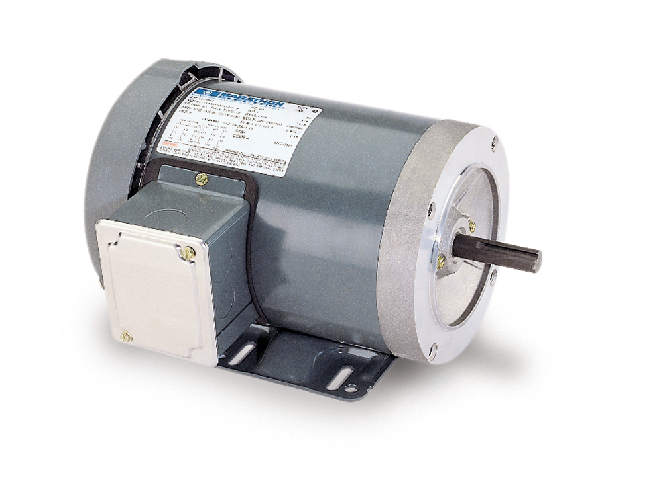 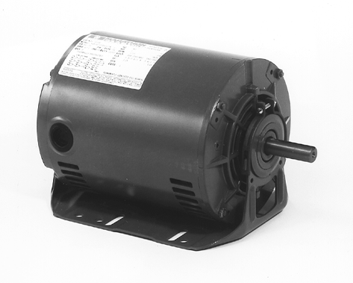
*Available in most 56 Frame constructions and features

Figure 1 TEFC Dripproof

LCS MOTOR PLATFORM
- Platform: CASA NEMA 56 Frame, 3PH product line
- Voltages: 230V, 460V
- Construction: TEFC, Open, DP, TEAO
- Speeds: 4-Pole, 6-Pole
- Mountings: Welded base, Resilient base, 56 Frame C-Face, Extended Clamp Bolts

APPLICATIONS
- Commercial Mixers, Pool Pumps, Restaurant Equipment
- Any application using a 3 phase motor with a VFD on a GFCI

BENEFITS/ADDERS
- Cost-savings due to reduced service calls (Adding a new GFCI or isolation transformer)
- Adder of $50-$75 depending on volumes and stack size
For further questions or inquiries, please contact Rich Steele.

