ATEX Zone 2 Hazardous Duty Motors
Frequently Asked Questions

Q. What does “ATEX” stand for?
A. “ATEX” is a French acronym meaning “Atmosphere Explosible”, and encompasses a series of standards pertaining to equipment and personnel within hazardous locations.

Q. What does “Zone 2” mean?
A. “Zones” refer to a general area classification associated with the likelihood or risk of explosion. This is comparable to “Divisions” used in context of North American NEC (National Electric Code) vernacular. Zone 2 and Division 2 are similar but not identical.

Q. What is the history and scope of ATEX?
A. ATEX consists of two separate European Directives (by the way, “directive” can be directly translated into “law”…the requirements are not optional), including Directive 1999/92/EC (date of enforcement 7/1/06) governing workplace safety and Directive 94/9/EC (date of enforcement 7/1/03) which deals with equipment such as electric motors placed into potentially hazardous environments. A major objective of ATEX, beyond protection of personnel and equipment, is development of a common European standard, as ATEX is enforced in all 24 member EU countries and their territories, plus Iceland, Norway and Liechtenstein.

Q. How are categories classified?
A. The broadest category defines both the area and risk of explosion: Area (aka Equipment Group) is defined as “Above-“ or “Below-Ground” (non-mining or mining…mining categories are M1 or M2). Risk is classified into zones, where Zone 0 defines an area in which an explosive atmosphere is continually present and is not applicable to motors, Zone 1 defines an area in which an explosive atmosphere is likely to occur in normal operation occasionally, and Zone 2 defines an area in which an explosive atmosphere is not likely to occur in normal operation, but if it does, only occurs for short periods. Just to make things even more interesting, while Zone 1 or 2 refer to gases, ATEX refers to their dust environments’ counterparts as Zone 21 or 22 respectively.

Q. What is “Equipment Category”?
A. Category 1 refers to Zone 0; category 2 refers to Zone 1; category 3 refers to Zone 2. This number is combined with a “G” for gas or “D” for dust to complete the equipment category. Thus, a Zone 2 motor suitable for flammable gases (within a defined gas group) would be listed as “3G”. Often, when a motor is suitable for flammable gases and combustible dusts, only the “D” (dust) follows the category number since dust standards are more stringent.

Q. Is there a difference between “Flameproof” and “Explosion Proof”?
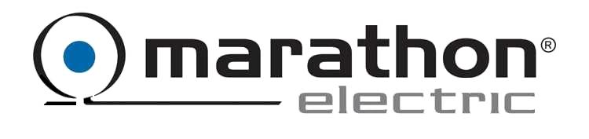A. Generally, there is no difference in construction. The term “Flameproof” (protection type “d”) applies to European standards, whereas “Explosion Proof” is used in NEC standards. Neither of these terms should be misinterpreted that “Flameproof” motors are IEC (metric) and “Explosion Proof” motors are NEMA.
ATEX Zone 2 Hazardous Duty motors
Frequently Asked Questions

Q. Are “groups” expressed differently in ATEX versus NEC standards?
A. Yes. But the good news is that each respective group contains the same gas substances.
NEC group ATEX group Substances
A IIC Acetylene
B IIC Hydrogen
C IIB Ethylene
D IIA Propane
“Group II” refers to non-mining.
As in the case of “Equipment Category”, the most stringent group is listed.

Q. What about Groups E, F and G?
A. ATEX defines Groups F and G in a “Zone 21” (“Flameproof”) motor. There are no defined groups for “Zone 22”. There is no such thing as “IIF” or “IIG” within ATEX; these groups are simply designated “D” (for dust) and the appropriate temperature code ensures the motor is placed into the appropriate atmosphere with the associated dust type (coal or grain dust). Metal dusts as defined in NEC Group E are not defined in ATEX. Ignitable flyings and fibers are considered to be a Class III environment. Motors for Class III are not available from Marathon.

Q. Can it get more complicated?
A. Yes. One source of confusion is that Canada expresses areas as zones versus divisions. However, while Zone 1 (in Canada) means essentially the same thing as Zone 1 in Europe, it is not accurate to assume that a Zone 1 labeled motor is ATEX Certified. Several years ago, Marathon changed the markings on our Explosion Proof motors to reference both Division and Zone. In order to verify a motor is ATEX Certified (for any zone), the CE Mark must accompany the other required nameplate markings.

Q. What about temperature codes?
A. Remarkably, temperature codes in the ATEX world have the same meaning as NA (NEC) standards. At one time, the IEC “in-between” codes (e.g. T2A) defined the actual temp (°C) but they have since adopted NEC nomenclature.
Temp C IEC/EU NEC
450 T1 T1
300 T2 T2
280 T2A (280) T2A
260 T2B (260) T2B
230 T2C (230) T2C
215 T2D (215) T2D
200 T3 T3
180 T3A (180) T3A
165 T3B (165) T3B
160 T3C (160) T3C
135 T4 T4
100 T5 T5
85 T6 T6
ATEX Zone 2 Hazardous Duty motors
Frequently Asked Questions

Q. Does Marathon Electric offer Zone 1 motors?
A. Not yet, but we’re very close. Regal-Beloit’s growing global presence has provided Marathon sources and outlets for our industry leading product lines, including access to Zone 1 motors manufactured in Europe. More details later.

Q. Do we have a product for Group III atmospheres?
A. No. Group III covers “ignitable fibers and flyings”, such as those found in textile mills. These substances are among the most hazardous and usually have very low flash points, requiring a very special motor.

Q. Do we have a product for Zone 0 atmospheres?
A. No. Zone 0 is not applicable to motors.

Q. What areas of opportunity do we have to sell ATEX motors?
A. By law, any facility within the European Union or its territories, including permanent structures located in European waters, must comply with the ATEX Directive including all electric motors, if the area is deemed to be hazardous in nature (Zone 1 or 2). Any US-based OEMs that build equipment for installation in Europe (any geography covered by the EU) must utilize ATEX motors. Any European based user that must replace the existing motor(s) on equipment manufactured by our customers must use an ATEX-compliant motor.

Q. What are the benefits of buying ATEX motors from Marathon Electric?
A. Marathon Electric is the recognized leader in the manufacture of Hazardous Duty™ motors within North America, and we have long-term relationships with many existing Explosion Proof customers. If those same customers export their equipment to Europe, the logical choice of ATEX motor suppliers is Marathon. As a domestic manufacturer, we offer a distinct lead-time advantage over European motor suppliers. The weak US dollar makes our products relatively less costly than an equivalent European competitor. Additionally, we can dual-rate our ATEX motors for both NEC (Division/Class/Group) and IEC/ATEX (Zone/Equipment Class/Group). Finally, Marathon is the leader in understanding and applying VFDs to motors and offers Inverter Duty ATEX motors.

Q. What does “Non-Sparking” mean?
A. Among about a dozen protection methods identified within ATEX (the “protection method” identifies a specific methodology to ensure the motor and surrounding equipment, buildings and personnel remain safe within a defined zone), “Non-Sparking” specifies a design that mitigates the risk of electrical sparking from mechanical or electrical sources. These include the use of conductive (non-sparking) fans, minimum air gap specifications and proper spacing of electrical terminals. “Non-Sparking” is identified as protection type “nA”.

Q. What other European Directives apply to electric motors?
A. There are too many for the context of this FAQ, but a few that may be familiar include (see page 4):

ATEX Zone 2 Hazardous Duty motors
Frequently Asked Questions

Low Voltage Directive (LVD); Ref: 73/23/EEC and 93/68/EEC
Electromagnetic Compatibility (EMC); Ref: 89/336/EEC, 92/31/EEC, 93/668/EEC
Machinery Directive (MD); Ref: 89/392/EEC, 91/368/EEC, 93/44/EEC, 93/68/EEC. “MD” is not applicable to electric motors.
ATEX Directive (ATEX): Ref: 94/9/EC
RoHS Directive (ROHS), Restriction on Use of Certain Hazardous Substances; Ref 2002/95/EC
WEEE Directive (WEEE), Directives on Waste Electrical and Electronic Equipment; Ref: 2002/96/EC
The CE Mark can only be applied to conforming equipment.

Q. What is a “Notified Body”?
A. Typically known as an “ENB” (European Notified Body), these are agencies like UL that test products and/or evaluate processes to ensure compliance with all applicable specifications and standards. The ENB then issues a Certificate, confirming that the manufacturer has met all of the ATEX requirements.

Q. Can a manufacturer “self-certify”?
A. Yes and No. Compliance with Zone 1 requirements must be confirmed by an independent third party (ENB). However, a manufacturer may choose to self-certify Zone 2 equipment. Marathon Electric’s practice has been to utilize a third party for all certifications and we recognize that this provides greater assurance to our customers and greater credibility to us as we develop the market.

Q. What is the minimum IP (Ingress Protection) requirement to comply with ATEX?
A. Minimum IP54 is required, wherein “5” is the degree of protection against solids (dust) and “4” defines the degree of protection from liquids entering the enclosure. Marathon Electric chose to incorporate IP56 to provide even greater assurance to our customers of the quality and construction of our product offering.

Q. Please explain the temperature code options.
A. See the following chart:

Q. Please explain the nameplate marking requirements.
A. See page 5 for a detailed breakdown of the nameplate markings.

ATEX Zone 2 Hazardous Duty motors
Frequently Asked Questions

Required nameplate markings

CE marking
ID # of Notified Body for the QA system (Intertek Testing & Certification, Ltd.)
EU Explosive Atmosphere symbol
Above ground (I=Mining, II=Non-mining)
Category (2=Zone 1, 3=Zone 2)
Gas (G) or Dust (D); if both, may list D only
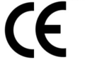 0359 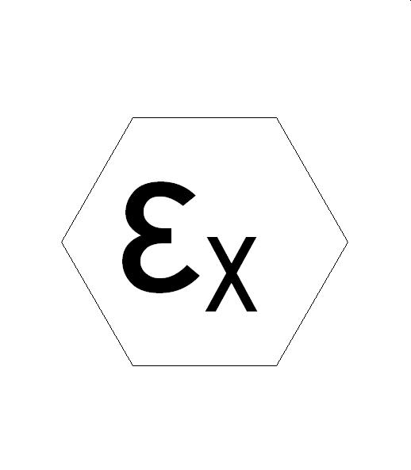 II 3 G

Explosion Protection
Protection Method
Gas Group (omit if Dust or if all gas groups included)
Temperature Code (see temp code markings in previous question)
Ingress Protection Code

Ex nA IIC T3 IP55

Q. What specific features comprise a Marathon Electric ATEX Zone 2 motor?
A. As a baseline, Marathon’s ATEX Zone 2 product is an all cast iron Severe Duty motor (EPAct or XRI® NEMA Premium®). Additional features are obviously dictated by the customer’s specification, but the minimum additional features include:
- IP56 protection (includes bearing isolator...Inpro/Seal or equal)
- Class F (minimum), Max Guard® insulation
- Bolt-on, explosion proof construction terminal box with silicone gasket
- ATEX Certified terminal block
- Thermistors
- External grounding terminal

Q. Can our standard stock motors be reworked in MOD Central to meet ATEX Zone 2 requirements?
A. No. All ATEX Certified motors are build-ups at this time.

Q. OK. Now how do I price a Marathon Electric ATEX Zone 2 motor?
A. Glad you asked. Please use the “List Price Adder” chart included in this release.

Q. What is the lead-time?
A. Current lead-time is approximately 4 weeks longer than that shown in the lead time letter, based on the frame size. Expect that to decline to normal lead time within the next six months.

